Name: Mehreen Aftab

**PROPOSAL NAME: “shortest path finding algorithm”**

**DESCRIPTION:**

In this project I would implement shortest path algorithm. There are many algorithms for finding shortest path such as dijisktras, bellmenford etc. I would implement dijisktras algorithm. There would be a simple window form appear and user would enter rows and columns for defining area. There would be another forms in which there would be three buttons of green , black and blue colour. Blue color is showing area, black will show you hurdles and green color would show you source to destination. User will click on these tiles and after that this software will generate all the possible paths and after the implementation of dijsktras algorithm , the software would find and detect the shortest path among all the paths. This would be very beneficial for the user.

**PROTOTYPE:**

**FORM:1**

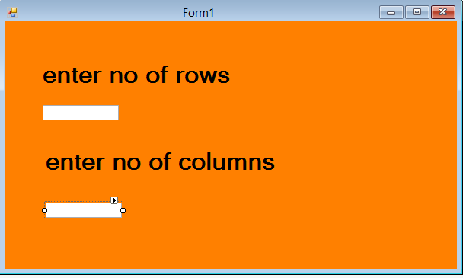

**FORM: 2**

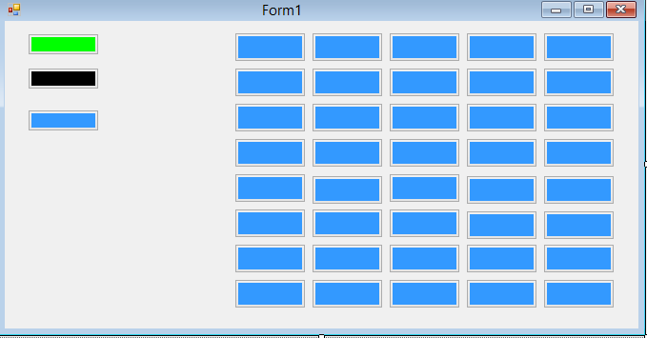

**FORM:3**

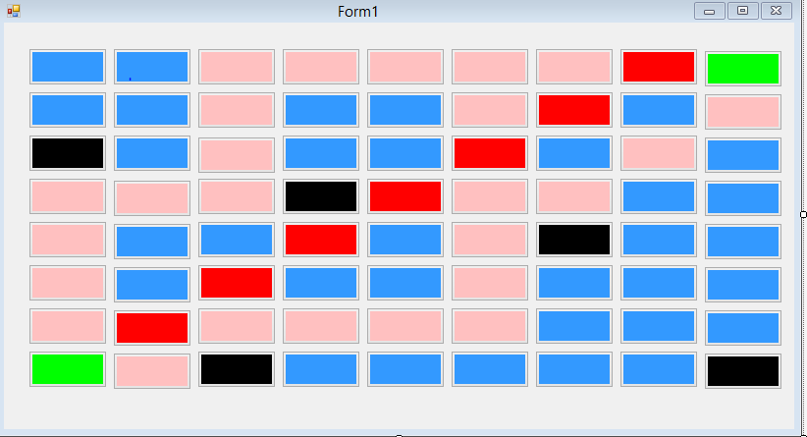

**WORK FLOW OF PROJECT**

Enter no of rows and column

Click run for execution

Click on green box

Click on black box

Click on blue box